**Winter Sports Rentals**

A winter sports rentals store needs an application that will let the user (a store clerk) enter information about each customer’s rental. The user should be able to select multiple equipment items, a rental duration, and insurance. Include a

check box showing that a liability waiver was signed, and let the user input the deposit amount. Use a combo box to list the rental durations, but do not let the user type in an arbitrary duration. When the user clicks the *Calculate* button, the application should calculate the subtotal, tax, and balance due. Also, use a LinkLabel control (*Weather forecast*) to display a second form containing a WebBrowser control.

The form containing the WebBrowser control, should display a series of links to weather forecasts for the area near the winter sports rental store. Place

a ToolStrip container at the top of the form; it should contain a text box (for entering a Web address), a *Go* button to navigate to the address typed into the text box, and a *Close* button that closes the browser window.

**Error Checking:** When the user clicks the *Calculate* button, make sure that at least one

item has been selected from the equipment list box. Also, a rental duration must have been selected, and the Deposit amount must be a positive number. Use the ErrorProvider control to display all error messages.

The following rental durations should appear in the combo box: 1 day, 2 days, 3 days, 1 week, 2 weeks.

**Calculations:** Each equipment item has a rental rate based on different durations. Create a two-dimensional array containing all possible rental rates. Each row should contain the rental rates for a single item, using the different rental durations. The following first row of the array, for example, contains rental rates for *Skis, beginner:*

35,45,80,150,280

For this equipment, the rates are $35.00 for 1 day, $45.00 for 2 days, $80.00 for 3 days, $150.00 for a week, and $280.00 for 2 weeks. Damage insurance costs 10 percent of the total rental charge before taxes.

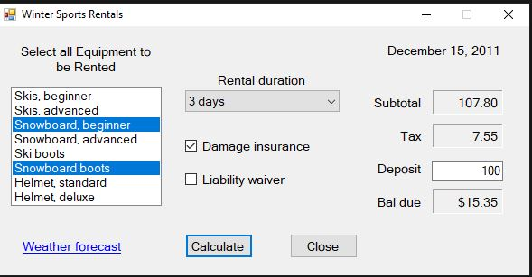

After user clicks the Weather Forecast link

